**AI in Bone Cancer Screening: A Comparative Analysis of Current Approach (DL)**

Vedashree B1, Tejashwini E2, Rajesh I S3, Sowmya V L4,

1,2,3,4 AIML Department, BMS Institute of Technology and Management, Bengaluru

**Abstract.** Bone cancer, though uncommon, presents notable diagnostic and treatment complexities due to its diverse manifestations and intricate nature. A reduced quality of life and incapacitating symptoms result from its development inside the skeletal system, which weakens and deteriorates bone function. Timely discovery is necessary to improve survival rates, yet traditional diagnostic methods are often unreliable and inaccurate. Developments in Artificial Intelligence (AI) and Deep Learning (DL) are revolutionizing this sector by improving the precision of tumor identification and classification through advanced imaging techniques such as MRIs, CT scans, and X-rays. This paper examines various types, symptoms, and stages of bone cancer while exploring cutting-edge diagnostic advancements. Special attention is given to deep learning frameworks like VGG16, DenseNet201, and ResNet101, outlining their contributions, challenges, and potential in advancing early detection and improving patient outcomes.

**Keywords:** Bone Tumor, Skeletal Oncology, Deep Learning models, Diagnostic Imaging , CNN.

1. Introduction

Cancer, often described as a malevolent neoplasm, is fundamentally a genetic disease caused by the uncontrolled growth of cells. In order to lower the death rates linked to this illness, early detection is essential. Uncontrolled cell proliferation is one of the main signs of cancer, which leads to the formation of malignant tumours capable of damaging nearby tissues. These tumours can further expand, interfering with critical bodily systems such as the circulatory, digestive, and nervous systems. Additionally, they may produce hormones that disrupt the normal functioning of the body.

A particularly concerning feature of cancer is its metastatic nature. Tumors can develop in new tissues as a result of this characteristic, which allows cancer cells to spread from their original location to other areas of the body. Common early symptoms of cancer include abnormal bleeding, the formation of new lumps, persistent coughing, changes in bowel movements, unexplained weight loss, and other health irregularities.

Bone cancer, a specific type of cancer, originates in the cells that form bone tissue. The most prevalent of its types, osteosarcoma typically affects the long bones in the arms and legs. Ewing sarcoma is a different kind that is more common in kids and teens. Another type of bone cancer is chondrosarcoma, which forms in cartilage. Furthermore, cancer that starts in another area of the body and spreads to the bones is known as metastatic bone cancer. However, enchondroma is a benign tumor that starts in cartilage and usually appears in larger bones like the thigh, shin, and upper arm bones as well as smaller ones like the hands.

It's unclear exactly what causes primary bone cancer, or cancer that starts in the bones. Nonetheless, it is connected to a number of risk factors:

* Genetic mutations: Some inherited conditions, such as Li-Fraumeni syndrome or hereditary retinoblastoma, increase the risk of bone cancer.
* Radiation exposure: Previous exposure to high doses of radiation, such as from cancer treatment, can raise the likelihood of developing bone cancer later in life.
* Bone diseases: Conditions like Paget's disease of the bone, which causes abnormal bone growth, can lead to a higher risk of bone cancer.
* Age and growth spurts: Osteosarcoma and other bone tumors may be more common in adolescents who are growing their bones quickly.
* Tumours can be classified into two types: cancerous (malignant) and non-cancerous (benign). Surgical removal of benign tumours is relatively easy, and most benign tumours do not grow back. However, compared to benign tumors, malignant tumors have larger nuclei(Fig. 1). This difference at the cellular level highlights how malignant tumors behave more aggressively, often growing rapidly and spreading into surrounding tissues or distant organs. Recognizing how these tumors evolve over time is essential for effective diagnosis and treatment. To manage bone cancer efficiently, doctors classify it into various stages that reflect how far the disease has progressed within the body.

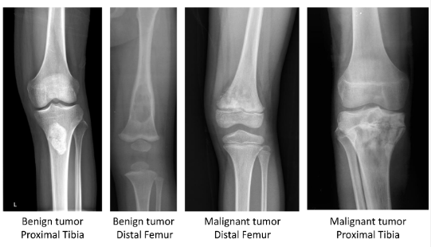

Fig. 1. Malignant and Benign Tumour

* 1. Stages of Bone Cancer

**Stage 0:"Cancer in Situ"**

Stage 0 is the earliest stage of bone cancer, often called "cancer in situ." The cancer cells are still there at this point, but they haven't spread outside of their original location. Because it is limited to the bone, the tumor is usually invisible without the use of sophisticated imaging methods.No symptoms; cancer is confined to one area within the bone, detectable only through advanced imaging techniques. (Fig. 2).

**Stage I: Early Localized Cancer**

In Stage I, the bone cancer remains localized to the bone. The lymph nodes and other remote areas of the body have not been affected by the tumor's spread. Stage I tumours are usually low-grade, meaning they grow slowly. (Fig. 2).

* **Key Features**: Minimal symptoms, localized tumour, no invasion into surrounding tissues.
* **Stage I-A**: With no metastases to other tissues, the tumor is little and restricted to a single bone. It usually develops slowly and is of low grade.
* **Stage I-B**: The tumour is larger, but still confined to the bone. Although it is high-grade (more aggressive), there is no spread to nearby lymph nodes or distant organs.

**Stage II: High-Grade Localized Cancer**

Stage II represents a more aggressive form of localized bone cancer. The tumour grows larger and is classified as high-grade, meaning it has a higher likelihood of spreading. However, it remains confined to the bone. (Fig. 2).

* + **Key Features**: Tumor grows larger, pain or swelling present, still no spread to distant areas.
  + **Stage II-A**: Despite being bigger, the tumor is still contained within the bone. It is high-grade, which means that although it hasn't spread yet, it is more likely to do so.
  + **Stage II-B**: The tumor is even larger, and there may be noticeable pain and swelling. It remains localized to the bone, but its aggressive nature increases the risk of future spread.

**Stage III: Regional Spread**

The spread of malignancy to several locations inside the same bone or to neighboring bones is a hallmark of stage III. At this stage, the cancer has not yet migrated to other parts of the body, but it has infiltrated the surrounding tissues. (Fig. 2).

* **Key Features**: Regional spread, more severe symptoms, may affect multiple areas in the bone or nearby tissues **.**
  + **Stage III-A**: The cancer has not progressed to other regions of the body, but it has expanded to other locations inside the same bone or to neighboring bones.
  + **Stage III-B**: The tumor may affect more than one location in the damaged bone, and the malignancy has spread to the nearby tissues and bones. Symptoms such as pain, swelling, and fractures may become more noticeable.
  + **Stage III-C:** It involves extensive spread within the bone or nearby bones and tissues, with a large tumor causing pain, swelling, and fractures. It has not spread to distant organs, and treatment targets local control and pain relief.

**Stage IV: Metastatic Bone Cancer**

Stage IV is the most advanced stage of bone cancer. Other bodily areas have been affected by the cancer's spread.,

such as the lungs, liver, or other distant organs. This is known as metastatic bone cancer.(Fig. 2).

* + **Key Features**: Widespread metastasis to other organs, more severe symptoms including systemic signs like weight loss and pain.
  + **Stage IV-A** The lungs are among the numerous bodily areas where cancer has spread.,liver, or distant bones, causing a more advanced metastatic stage.
  + **Stage IV-B**: The cancer involves multiple distant organs or bones, and symptoms are more severe. This stage may include systemic effects such as weight loss, fatigue, and difficulty moving.

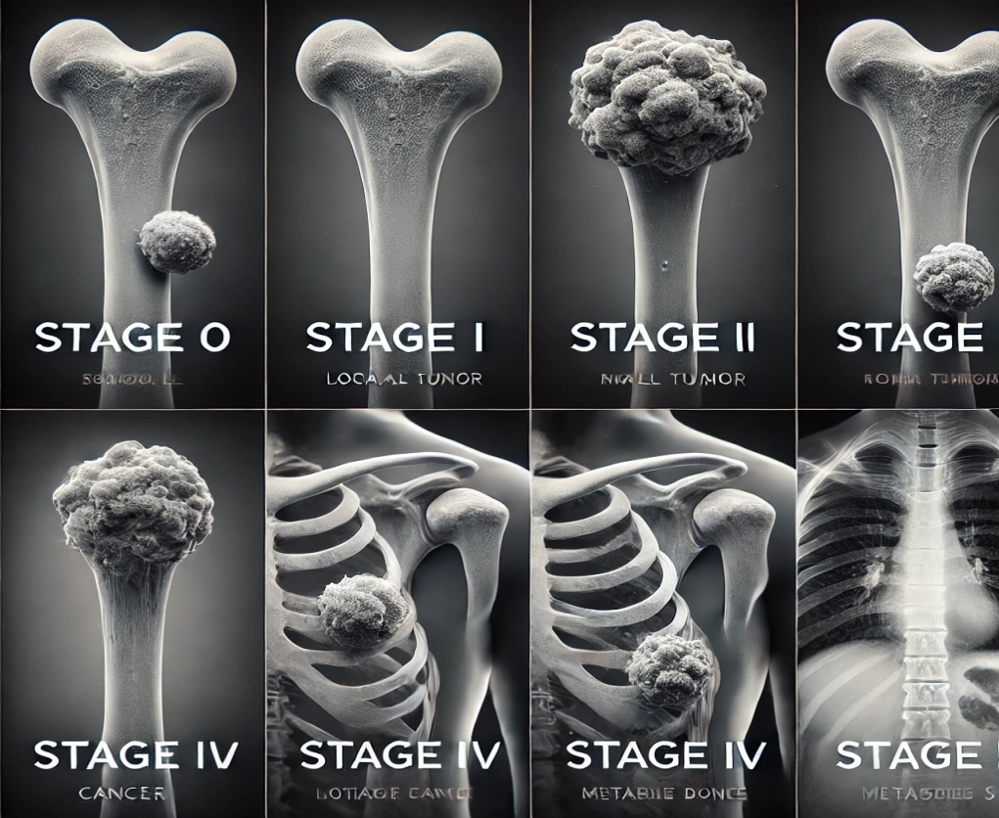

Fig. 2 .Stages of Bone Tumour

The tumor size descriptions for each stage of bone cancer are provided in Table 1.

Table 1. Tumour size of stages of bone cancer

|  |  |  |
| --- | --- | --- |
| **Stages of bone cancer** | **Tumour size** | **Spread(Lymph node status)** |
| Stage 0 | Small, localized | No spread |
| Stage IA | Small, <= 2 cm | No spread to other tissues or organs |
| Stage IB | Larger, <= 5 cm | No spread to lymph nodes or distant organs |
| Stage IIA | Larger, > 5 cm | No spread to distant organs |
| Stage IIB | Larger, > 5 cm | No spread to distant organs |
| Stage IIIA | Large, > 5 cm | Spread within the bone or to nearby bones |
| Stage IIIB | Larger, > 5 cm | Spread to surrounding tissues and bones |
| Stage IIIC | Very large, > 5 cm | No spread to distant organs |
| Stage IV-A | Tumor may vary in size | Spread to distant organs (lungs, liver, etc.) |
| Stage IV-B | Tumor may vary in size | Spread to multiple distant organs |

Bone cancer may show no symptoms in early stages, making detection difficult. As it advances, common signs include persistent bone pain, swelling, limited movement, and fractures. In later stages, fatigue, weight loss, or breathing problems may occur. Early symptom recognition is key to timely treatment.

* 1. Symptoms of Bone Cancer

Bone cancer may manifest in a variety of ways, including:

* Pain: A persistent bone or joint ache that gets worse over time and doesn't go away when you use painkillers. The pain may be worse at night or during activity.
* Swelling: Swelling or redness over the bone, which can make it difficult to move the joint.
* Lump: A noticeable lump over the bone.
* Fracture: A week bone that break more easily than normal. This is called pathological fracture.
* Other symptoms: Weight loss that isn't explained, fatigue, fever, perspiration, or loss of sensation in the afflicted limb.
* Although bone cancer can grow in any bone, it typically affects the long bones of the upper arms or legs. The kind, stage, and location of bone cancer can all affect how painful it is.

1. Diagnostic Imaging Modalities for Bone Tumor Detection

**X-rays**  
X-rays are often the first imaging technique used to detect bone cancer. In X-ray images, cancerous bone tissue typically appears different from healthy bone. While X-rays can reveal tumours and abnormal growths, they don't give enough information to make a conclusive diagnosis(Figure 4 a,b,c).

**MRI Scan**

MRI provides detailed imaging to evaluate the tumour's contents, such as fat, water, and blood, based on signal patterns Figure (4 g,h,i).It helps to differentiate tumour recurrence from changes caused by prior treatments. Contrast-enhanced MRI highlights tumour vascularity and post-treatment changes, aiding in biopsy planning by avoiding necrotic areas. Useful for local staging, treatment monitoring, and assessing tumour spread to joints, muscles, and neurovascular structures. Signal patterns:

* + - **Low T1 and high T2 signals**: Presence of free water.
    - **High signals on both T1 and T2**: Presence of fat.
    - **Low signals on both**: Presence of cortical bone, fibrosis, calcifications, or air (Figure 3).

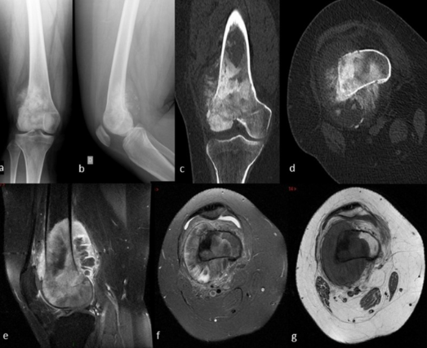

Fig. 3. (3.a/b) Anteroposterior and lateral radiographs of knee (3.c/d) Coronal and axial views on computed tomography (3.e/g) T1 sagittal view, T2 fat supressed axial and T1 sag Fat suppressed axial views on magnetic resonance imaging.

**Anteroposterior and lateral radiographs of the knee**: Standard X-ray views used to assess the alignment and structure of the knee joint. (Fig. 3.a/b).

**Coronal and axial views on computed tomography**: CT scans providing detailed images of the knee from different angles to evaluate bone and soft tissue conditions. (Fig. 3.c/d).

**T1 sagittal view on magnetic resonance imaging**: MRI scan providing a side view of the knee, highlighting bone and soft tissue with good contrast. (Fig. 3.e/g).

**T2 fat-suppressed axial view on MRI**: MRI sequence enhancing the visibility of fluid-filled structures like cartilage and ligaments by suppressing fat signals. (Fig. 3.e/g).

**T1 fat-suppressed axial view on MRI**: MRI imaging technique used to improve the contrast of tissues by suppressing the fat signals in the knee joint. (Fig. 3.e/g).

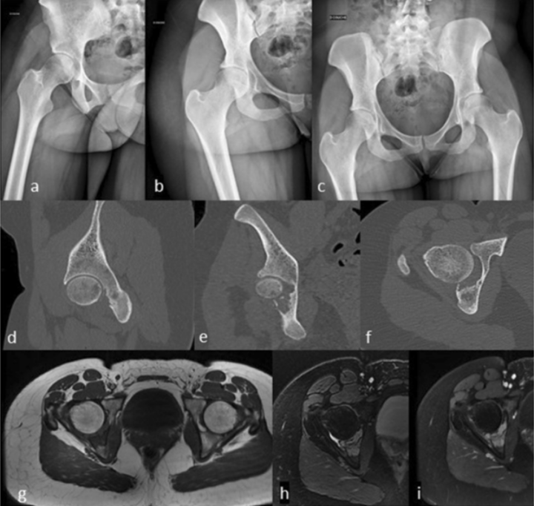

Fig. 4. (4.a/c)Standard radiographs of hip (4d/f)Sagittal, frontal, and axial views on computed tomography (4. g/i) T1 and T2 axial and T1 gadolinium-enhanced axial views on magnetic resonance imaging.

**Standard radiographs** : **Standard radiographs** of the hip showing structural abnormalities indicative of potential bone lesions. (Fig. 4.a/c).

**Sagittal, frontal, and axial views on computed tomography :**Sagittal, frontal, and axial CT views illustrating detailed cross-sectional imaging of the hip region for tumor visualization. (Fig. 4.d/f).

**T1 axial, T2 axial, and T1 gadolinium-enhanced axial MRI :** Itviews providing high-resolution images of the hip to evaluate tumor characteristics and vascularity. (Fig. 4.g/i).

**CT Scan**

A CT scan combines X-rays and computer technology to create detailed, cross-sectional images of bones and surrounding tissues (Fig. 5).Allows visualization of the location, size, and shape of tumours or abnormalities. Detects primary bone cancers (originating in the bone) and metastatic bone cancers (spreading from other body parts).Also monitors treatment response and checks for cancer recurrence.

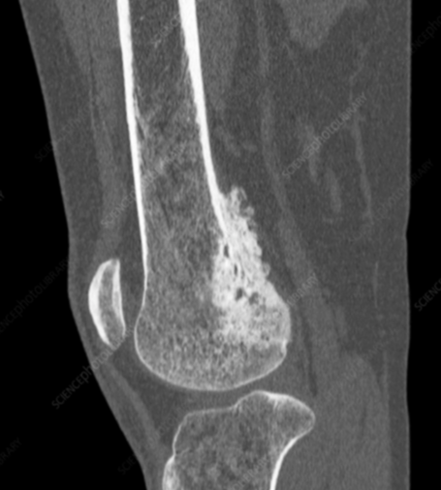

Fig. 5. CT Scan of a Bone

**Bone Scan**

A bone scan is a specialized imaging test that detects abnormalities in the bones, including cancer. A special camera captures images, highlighting "hot spots" where the tracer collects more intensely, often indicating tumours or cancerous activity. These areas appear as darker or more intense regions on the scan, helping identify the presence and location of cancer.(Fig. 6).Building on these imaging techniques, the next section explores how deep learning models—particularly Convolutional Neural Networks (CNNs)—are transforming the detection of bone cancer through automated medical image analysis.

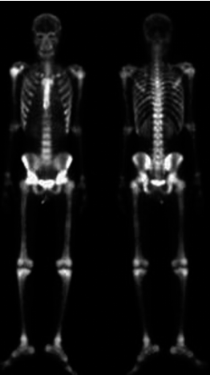

Fig 6 .Bone Scan

1. Deep Learning-Based Convolutional Models for Bone Cancer Detection

By analyzing medical pictures and learning to recognize important characteristics linked to bone malignancies, CNN models like VGG16, VGG19, DenseNet201, and ResNet101 are essential in the detection of bone malignancy(Fig. 7). The assessment metrics guarantee that the model chosen for clinical application is optimum for accuracy and dependability. The figure describes how medical picture classification for bone cancer diagnosis using deep learning (DL) models, namely Convolutional Neural Networks (CNNs). The steps are as follows:

1. **Input Dataset**: The model uses medical images such as X-rays, CT scans, or MRIs to detect bone abnormalities, including tumors and metastasis.
2. **Image Processing**: Different CNN architectures are applied to process the images and extract patterns:
   * **VGG16 & VGG19**: Simple, effective models with multiple convolutional and fully connected layers, suitable for identifying bone lesions.
   * **DenseNet201**: Enhances feature learning by utilizing dense connections between layers,helping detect smaller tumors.
   * **ResNet101**: Employs deep residual connections to manage complex images and detect subtle features of bone cancer.
3. **Performance Evaluation**: The models effectiveness is assessed using metrics like:
   * **Accuracy**: Measures overall correctness.
   * **Recall**: Indicates the model’s ability to detect all cancerous images.
   * **Precision**: Measures the accuracy of predicted cancerous images.
   * **F1 Score**: Balances recall and precision.
   * **AUC**: Assesses the model's ability to distinguish between cancerous and non-cancerous images.
4. **Model Selection**: After evaluating these performance metrics, the best model is chosen for deployment, aiding in earlier detection and better treatment decisions for bone cancer.

Performance Parameters[Accuracy,Recall,F1 score,Precision,AUC vscore

Fig. 7. Common Architectures of DL Models

Some of the common and existing CNN models to detect Bone Cancer:

**VGGNet**: VGGNet, with its deep architecture and use of small convolutional filters,contributes significantly to bone cancer detection by effectively recognizing patterns in medical images. The network’s multiple convolutional layers help extract detailed features from images like X-rays or MRIs, which are essential for locating anomalies like tumors or bone lesions. It is ideally suited for examining bone scans because to its ease of use and efficiency in image categorization tasks. By processing these images, VGGNet helps detect potential bone cancer, providing clinicians with accurate insights for early diagnosis and treatment (Fig. 8).

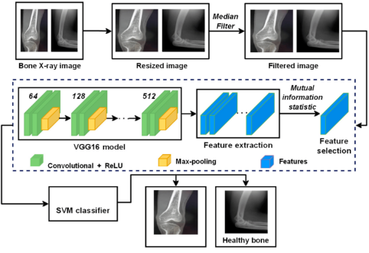

Fig. 8. VGGNet A deep transfer-Based bone cancer Diagnostic system.

**DenseNet201**: A deep learning model called DenseNet201 was created especially for picture analysis,making it ideal for detecting bone cancer in medical images like X-rays and CT scans. It works by leveraging dense connections between layers, allowing the model to reuse features and capture intricate details,this is crucial for spotting minute patterns linked to bone cancer. It is appropriate for smaller datasets due to its effective parameter usage,common in medical imaging. Additionally, DenseNet201 addresses the vanishing gradient problem, ensuring effective training even with complex medical images. This architecture achieves high accuracy, which is critical for tasks such as detecting metastatic bone cancer from histopathology slides, classifying bone tumors in radiographs, and identifying fractures or abnormalities in orthopedic imaging that might indicate underlying malignancies. By providing reliable and accurate results, DenseNet201 supports early detection and improves the chances of successful treatment.(Fig. 9).

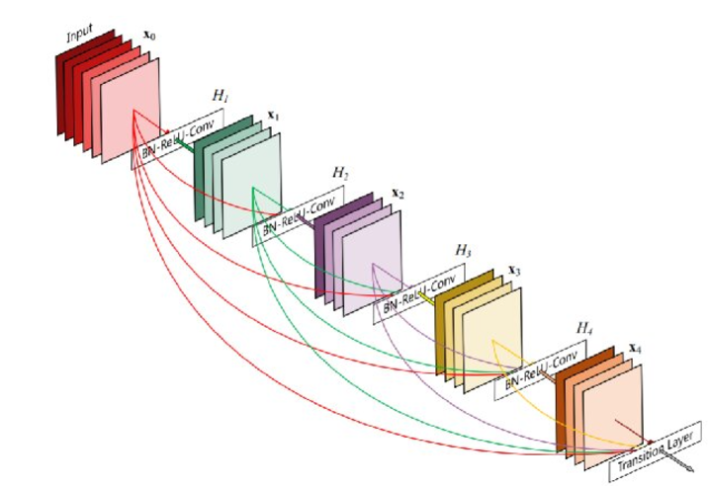

Fig. 9. DenseNet201 Architecture

**AlexNet**: An early but influential CNN architecture, efficient for classifying images with a rather straightforward structure.(Figure10).This architecture helps identify bone cancer by analysing key patterns and abnormalities in medical images, assisting in early detection for better outcomes.(Fig. 10).This CNN architecture helps detect bone cancer by processing medical images like X-rays or CT scans. The steps are as follows:

* **Normalization**: Adjusts images for consistency, ensuring they’re all on the same scale for better analysis.
* **Resizing & Cropping**: Makes sure all images are the same size and focuses on important areas of the bone where cancer might be present.
* **Data Augmentation**: Creates variations of the images (like rotating or flipping) to help the model learn more and perform better, especially when there’s limited data.
* **Convolution (with ReLU)**: Extracts important features like bone edges and possible tumors by filtering the images, with ReLU helping to focus on the most relevant parts.
* **Max Pooling**: Reduces image size while keeping the essential features, making the model faster and more efficient.
* **Fully Connected Layers**: Combines the extracted features to analyze the image and determine if cancer is present.
* **Global Pooling**: Looks at the whole image to ensure all potential cancer signs across the bone are considered.
* **Final Classification**: The model’s last decision-making step, where it classifies the image as either showing bone cancer or not based on the features learned.

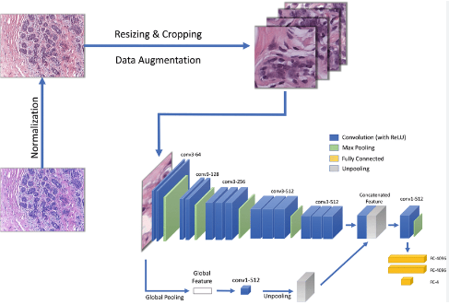

Fig. 10. CNN AlexNet Architecture

**ResNet** : ResNet (Residual Network) is a deep learning architecture developed to address the vanishing gradient problem, enabling the training of very deep neural networks. This methodology outlines the application of ResNet for bone cancer detection using medical images, focusing on architecture design, training, and evaluation. The initial steps involve gathering a comprehensive dataset of medical images and preprocessing them to ensure quality and consistency. The Basic Building Block is Residual Block and core component of ResNet is the residual block, which facilitates the training of deep networks by allowing gradients to flow through shortcut connections(Fig. 11).

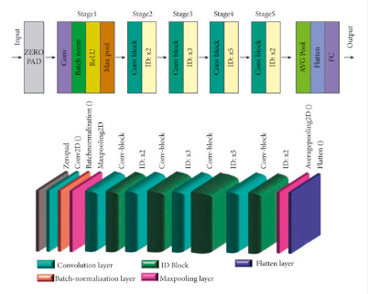

Fig. 11. ResNet Architecture

Table 2. Comparative Analysis of Deep Learning Modalities

|  |  |  |  |  |  |
| --- | --- | --- | --- | --- | --- |
| **Model** | **Architecture** | **Strengths** | **Best For** | **Computational Complexity** | **Suitability for Bone Cancer Detection** |
| VGGNet | Deep network with small convolutional filters | Simplicity, effectiveness in image classification, and good at recognizing patterns | Identifying bone lesions and tumors in medical images like X-rays and MRIs | Moderate | Good in identifying broad patterns, but because of its simplicity, it could find it difficult to complete complex tasks. |
| DenseNet201 | Deep network with dense connections between layers | Efficient feature reuse, high accuracy, tackles vanishing gradient problem, ideal for small datasets | Detecting subtle patterns in bone cancer, such as metastasis and fractures | High | Excellent for identifying subtle bone cancer features with smaller datasets. |
| AlexNet | Early CNN architecture with multiple layers | Good for general image classification tasks, simpler structure | Detecting bone cancer in X-rays and CT scans | Low to moderate | Effective for basic bone cancer detection, but may not capture intricate details. |
| ResNet101 | Deep residual network with residual blocks | Addresses vanishing gradient problem, capable of training very deep networks, efficient for large images | Detecting subtle features of bone cancer in complex medical images | High | Excellent for complex medical images due to its deep architecture and residual connections. |

1. Literature Survey

AI is employed in bone cancer detection through advanced techniques such as deep learning which analyse medical images to identify tumours with high accuracy. These methods enhance early diagnosis , improve screening processes, and assist radiologists by providing reliable and swift interpretations of mammograms and other imaging modalities. Table 3 provide a description of the many approaches, strategies, and datasets that different authors have utilised to identify bone cancer. We also point out different benefits and difficulties that come with employing these techniques. In table 4, the illustration and description about the literature survey is given

Table 3.Literature survey on bone cancer detection

|  |  |  |  |  |
| --- | --- | --- | --- | --- |
| **Authors** | **Methods/Techniques** | **Dataset** | **Merits** | **Demerits** |
| Vlad Alexandru Georgeanu, Madalin Mamuleanu et.all(2000) | Deep learning Algorithms  Transfer learning  Data preprocessing  Training and Validation | Large number of labelled medical images, such as MRI scans etc. | Innovative Approach  Clinical Relevance  High Accuracy  Potential Impact | Limited Generalizability  Data Bias  Interpretability  Clinical Integration  Ethical Considerations  Model Robustness |
| Prisca Honore, PharmD, PhD, and Patrick W. Mantyh, PhD(2000) | Electrophysiological recordings Immunohistochemistry  Molecular biology techniques  Clinical studies | Mouse Model and Therapeutic Intervention | Robustness of findings  Translational relevance  Therapeutic development  Mechanistic insights | Complexity and resource  Integration Challenges  Interpretation bias  Reproducibility issues |
| Pu Chen, Run Chen, Nan Chen, Lan Zhang, Li Zhang, Jianfeng Zhu, Wei Guo et.al (2018) | Image Acquisition and Preprocessing Deep Learning Algorithms  Training and validation  Clinical Application | Dataset by Zhongshan Hospital | Improved Accuracy  Efficiency  Reliability  Diagnostic Support  Clinical Utility  Scalability | Limited sensitivity  Complexity of Analysis  Cost and Resource requirements  Validation and Generalizability |
| D. Anand, G.Avulselvi, G.N. Balaji and G Rajesh Chandra  (2018) | Support vector machine  Logistic Regression  Naïve Bayes  K-Nearest neighbor  Decision tree | DC-LEM | Improved Accuracy  Reduced Misdiagnosis  Efficiency and automation  Standardized Analysis | Data Dependency  Overfitting  Lack of Explainability  Computational Cost  Generalizability |
| Eftekhar Hossain and Mohammad Rahaman  (2018) | Fuzzy -mean clustering  Adaptive Neuro Fuzzy Inference System Cross Validation  Performance metrics | The Cancer Imaging Archive  Image Data Resource  National Institutes of Health Clinical Centre | Image Analysis  Cross-Validation  Clinical Relevance | Limited Sample Size  Lack of Comparison  Data Heterogeneity  Interpretability  Clinical Validation  Computational Complexity |
| Eliodoro Faiella, Domiziana Santucci, Alessandro Calabrese , Fabrizio et.al(2019) | Literature Review  Selection Criteria  Data Extraction  Radiomics Quality Score(RQS) | Radiomics based mri signatures and Dca | Comprehensive Literature Review  Clear Selection Criteria  Critical Appraisal  Interpretation of Results | Publication Bias  Limited Search Strategy  Lack of Meta-Analysis  Interpretation Bias  Generalizability |
| Chan-Woo Park, Seong-Je Oh, Kyung-Su Kim, Min-Chang Jang , et.al(2020) | Data Collection,Pre-ProcessingDeep Learning  Performance Evaluation  Comparison with Human Doctors | Radiographic images and proximal femur | Clinical Relevance  Novel Approach  Potential Clinical Impact  Generalizability | Dataset Limitations  Lack of External Validation  Interpretability of AI Model  Ethical Considerations  Limited Comparative Analysis |
| Deepshikha Shrivastava (2020) | Decision Tree Algorithm, Support Vector Machine (SVM), Random Forest (RF), Evolutionary Algorithms, Swarm Intelligence (PSO, ACO) | Not specified | Efficient classification, handles large datasets, uses weak learners for improved performance, optimizes with Evolutionary Algorithms. | May suffer from overfitting, complexity in integrating multiple methods, lack of interpretability in some cases. |
| Ashish Sharma (2021) | Canny edge detection, Support Vector Machine (SVM), Random Forest (RF), Histogram of Oriented Gradients (HOG) | Bone images (specific dataset not provided) | Improved accuracy in bone cancer detection, effective for segmentation, integration of HOG features enhances performance | May not generalize well to other types of cancer, sensitive to noise in image preprocessing. |
| Pu Chen (2021) | CNN Architecture, Image processing with convolution and pooling layers | Morphogo acquisition terminal images (dataset not fully specified) | Enhances detection efficiency with CNNs, combination of pathologists and Morphogo improves accuracy | Dependency on pathologist input, limited scalability in other scenarios. |
| Xiawen Zhou et al.(2022) | Convolutional neural networks (CNNs), transfer learning, data augmentation, evaluation metrics | Radiological images, CT and MRI datasets, additional medical imaging | Improved diagnostic accuracy, efficient tumor segmentation, research advancements, future clinical applications | Data limitations, interpretability and explainability, validation and clinical utility, resource requirements, human-AI collaboration |

Table 4. Illustration of Literature Survey

|  |  |
| --- | --- |
| DESCRIPTION | RESULTS |
| Deepshikha Shrivastava (2020) used Decision Tree Algorithm: It uses a divide-and-conquer approach, Random Forest (RF) controls the complexity and error frequency, while Support Vector Machine (SVM) determines the classification rules based on the paths followed through the tree. It effectively handles large datasets and leverages the concept of "weak learners" combining to form a "strong learner." Evolutionary Algorithms: They evolve a population of candidate solutions over generations, applying operations like crossover and mutation based on a fitness function that measures solution accuracy. Swarm Intelligence (SI): Algorithms such as Particle Swarm Optimization (PSO) and Ant Colony Optimization (ACO) are notable examples used to solve complex problems.[20] | Fig. 12. (A) Axial views of a CT scan (B) top view of CT scan |
| Ashish Sharma (2021)  The segmentation of bone images is performed using the Canny edge detection technique. This method helps to highlight the boundaries of structures within the images. Training and classification are done using Random Forest (RF) and Support Vector Machine (SVM) methods. The SVM provides a discriminative model that defines optimal hyperplanes to separate classes based on the features extracted. When compared to methods without these features, the use of HOG features improves the ability to distinguish between images of healthy and malignant bones.[6] | Fig. 13. Image with hog feature. |
| Sushopti Gawade(2023)  VGG16: This architecture consists of 16 layers with weights, utilizing small 3 × 3 convolution filters and 2 × 2 max-pooling layers. VGG19: Similar to VGG16 but with 19 layers, this architecture also uses small 3 × 3 convolution filters. DenseNet 201:It has 201 layers and is effective in tasks like object detection and image classification. ResNet101: ResNet101, created by Microsoft, learns residual functions instead of direct mappings by using residual connections.[14] | Fig. 14. Validation accuracy of all models. |
| Eftekhar Hossain(2018)  Grayscale Conversion: To simplify the analysis and reduce computational complexity, the RGB format MR images are converted to grayscale.  The five matrices are Entropy, Energy Contrast, Homogeneity, Correlation. Fuzzy C-means Clustering: This method applies fuzzy logic to segment the image. Soft segmentation is made possible by assigning each pixel a membership value that indicates how much it belongs to certain clusters. ANFIS Classifier: To maximize tumor classification, the Adaptive Neuro-Fuzzy Inference System (ANFIS) combines fuzzy logic and neural networks.[9] | Fig. 15 . Steps for bone Tumour detection using fuzzy C-mean clustering: (a) Bone MR image (b) Grayscale image (c) Clustered image (d) Detected Tumour |
| Pu Chen(2021)  CNN Architecture and Training Details : The acquisition terminal from Morphogo has a convolutional neural network with fully linked, pooling, and convolution layers. The convolution filter is used to modify or enhance the cell cluster image by emphasizing or removing certain features in image processing.  Combining the capabilities of both Morphogo and pathologists may enhance the detection efficiency and accuracy of cancer cell clusters, ultimately saving valuable time for medical professionals.[7] | Fig. 16. The correlation of ROC curve between Morphogo and pathologists |
| Vlad Alexandru Georgeanu (2022)  The proposed system employs two ResNet50 models to process MRI scans. For efficient training, ResNet50 needs a sizable dataset; transfer learning was used to train the models in this investigation. The initial weights came from networks that had already been trained on the ImageNet dataset, which has 20,000 classes and over 14 million labeled images. This methodical strategy uses both cutting-edge deep learning techniques and pertinent clinical data to enhance the prediction of bone tumor malignancy.[4] | Fig. 17. ResNet50architecture |

* 1. Statistical Analysis

Table 5. presents statistics on bone cancer cases in India.

Table 5. presents statistics on bone cancer cases in India

|  |  |  |  |  |
| --- | --- | --- | --- | --- |
| **Year** | **Estimated Incidence Rate(per 100,000)** | **Estimated Mortality Rate(per 100,000)** | **Common Age Group Affected** | **Male-to-Female Ratio** |
| 2020 | 0.7 | 0.5 | 10-30 years | 1.5:1 |
| 2021 | 0.7 | 0.5 | 10-30 years | 1.5:1 |
| 2022 | 0.8 | 0.5 | 10-30 years | 1.6:1 |
| 2023 | 0.8 | 0.5 | 10-30 years | 1.6:1 |

Fig. 18 Depicts the Male-to-Female distribution of bone cancer cases.

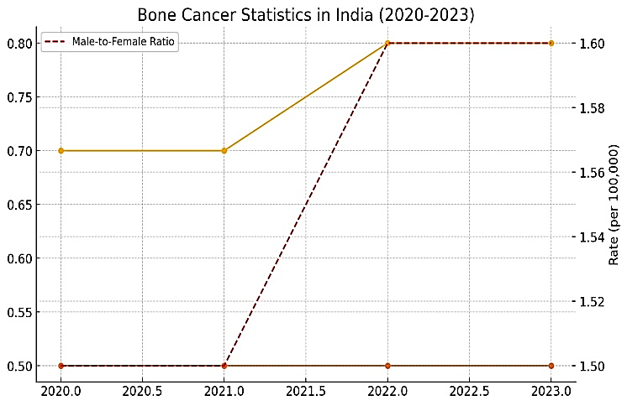

Fig. 18. Bone cancer Male-to-Female distribution

4.2 Issues in Detection Of Bone cancer

* Early-stage bone cancers are difficult to detect due to their small size and subtle signs, making them prone to being missed by imaging techniques.
* Distinguishing between benign bone lesions and malignant tumors is challenging, as they can appear similar on scans, leading to potential misdiagnosis.
* Both false positives (non-cancerous abnormalities flagged as cancer) and false negatives (missed cancerous growths) reduce the precision and dependability of techniques for detecting bone malignancy.
* Variability in radiologist interpretation can result in inconsistent diagnoses, especially when the cancerous signs are subtle or ambiguous.
* Identifying metastatic bone cancer, especially differentiating it from primary bone cancer, is difficult and often requires advanced diagnostic techniques.
* Why AI models developed on certain datasets could not perform well in real-world clinical situations since they don't generalize well to different demographics or imaging devices.
* In younger individuals, denser bone tissue and ongoing bone development make it harder to detect tumors, complicating early diagnosis.
* The creation of reliable and accurate bone cancer detection systems is hampered by the unavailability of sizable, high-quality annotated datasets for deep learning model training.
* The deployment of sophisticated AI models in low-resource environments is restricted by their high computational resource requirements, such as Convolutional Neural Networks (CNNs).
* The black-box nature of AI models makes it difficult for clinicians to understand the reasoning behind predictions, potentially hindering the adoption of AI in clinical practice.

1. Conclusion

There is much promise for improving diagnostic accuracy in the identification of bone cancer through the use of deep learning, namely Convolutional Neural Networks (CNNs). Because of their capacity to recognize intricate patterns and learn from big datasets, DenseNet and ResNet have been shown to be the most successful CNN architectures for medical imaging applications. DenseNet is a very effective model for detecting bone cancer because of its dense connection, which enables more effective feature extraction with fewer parameters. Although CNNs like VGGNet and AlexNet have also made contributions to the field, the more sophisticated architectures are better suited for complicated tasks due to their relative simplicity and computing requirements.

Despite these developments, problems including data bias, interpretability, and the requirement for sizable, superior annotated datasets still make it difficult for deep learning models to be widely used in clinical settings. Furthermore, overcoming obstacles pertaining to validation, resource needs, and guaranteeing these technologies' practical applicability in various healthcare settings are necessary for their adoption into clinical practice .Continued research is essential to refine these models, address existing limitations, and develop more effective, scalable solutions for early bone cancer detection, ultimately improving patient outcomes.

6. References

[1] Deng, J., Dong, W., Socher, R., Li, L. J., Li, K., & Fei-Fei, L. (2009). ImageNet: A large-scale hierarchical image database. In 2009 IEEE conference on computer vision and pattern recognition (pp. 248-255).

[2] He, K., Zhang, X., Ren, S., & Sun, J. (2016). Deep residual learning for image recognition. In Proceedings of the IEEE conference on computer vision and pattern recognition (pp. 770-778).

[3] Szegedy, C., Ioffe, S., Vanhoucke, V., & Alemi, A. (2017). Inception-v4, inception-resnet and the impact of residual connections on learning. In Thirty-first AAAI conference on artificial intelligence.

[4] Vlad Alexandru Georgeanu et al. (2022). Malignant Bone Tumours Diagnosis Using Magnetic Resonance Imaging Based on Deep Learning Algorithms.

[5] Prisca Honore and Patrick W. Mantyh (2000). Bone Cancer Pain: From Mechanism to Model to Therapy.

[6] Ashish Sharma et al. (2021). Bone Cancer Detection Using Feature Extraction Based Machine Learning Model.

[7] Pu Chen et al. (2021). Detection of Metastatic Tumour Cells in the Bone Marrow Aspirate Smears by Artificial Intelligence (AI)-Based Morphogo System.

[8]D. Anand et al. (2022). A Deep Convolutional Extreme Machine Learning Classification Method To Detect Bone Cancer From Histopathological Images.

[9] Eftekhar Hossain and Mohammad Rahaman (2020). Bone Cancer Detection & Classification Using Fuzzy Clustering & Neuro Fuzzy Classifier.

[10] Eliodoro Faiella et al. (2022). Artificial Intelligence in Bone Metastases: An MRI and CT Imaging Review.

[11] Xiaowen Zhou et al. (2022). Emerging Applications of Deep Learning in Bone Tumours: Current Advances and Challenges.

[12] Xin-hui Du et al. (2020). Artificial Intelligence (AI) Assisted CT/MRI Image Fusion Technique in Preoperative Evaluation of a Pelvic Bone Osteosarcoma.

[13] Chan-Woo Park et al. (2022). Artificial intelligence-based classification of bone Tumours in the proximal femur on plain radiographs: System development and validation.

[14] Sushopti Gawade et al. (2023). Application of the convolutional neural networks and supervised deep-learning methods for osteosarcoma bone cancer detection.

[15] Kanimozhi Sampath et al. (2024). A comparative analysis of CNN-based deep learning architectures for early diagnosis of bone cancer using CT images.

[16] Sebastian Breden et al. (2024). Deep Learning-Based Detection of Bone Tumours around the Knee in X-rays of Children.

[17] Sushopti Gawade et al. (2023). Application of the convolutional neural networks and supervised deep-learning methods for osteosarcoma bone cancer detection.

[18] Xiaowen Zhou et al. (2022). Emerging Applications of Deep Learning in Bone Tumours: Current Advances and Challenges.

[19] Eatedal Alabdulkreem et al. (2024). Bone Cancer Detection and Classification Using Owl Search Algorithm With Deep Learning on X-Ray Images.

[20] Deepshikha Shrivastava et al. (2020). Bone cancer detection using machine learning techniques in the book *Smart Healthcare for Disease Diagnosis and Prevention*.